LAB EXPERIMENT 7
NAME: Furthose samreen B
REG NO:192511164
7.You are designing a Task Management System for a small team. The system should include the following features.
AIM
To prioritize the requirements of a Task Management System for a small team using the MoSCoW and Kano prioritization models in Jira to identify essential features and improve project planning.
PROCEDURE
- Open Jira and create a new project named Task Management System.
- Create four Jira issues for the following requirements:
  - User Login and Role Assignment
  - Task Creation and Assignment
  - Task Prioritization and Deadlines
  - Progress Tracking and Reporting
- Use the MoSCoW model to classify requirements into Must Have, Should Have, Could Have, and Won't Have.
- Use the Kano model to classify requirements into Must-be, Performance, Attractive, and Indifferent categories.
- Add the prioritization details using Jira labels or custom fields.
- Assign tasks to team members and update their priorities.
- Save the issues and review the prioritized requirements
REQUIREMENT PRIORITIZATION
1. MoSCoW Model
Requirement | Priority | Explanation
User Login and Role Assignment | Must Have | Essential for secure access.
Task Creation and Assignment | Must Have | Required to manage team tasks.
Task Prioritization and Deadlines | Should Have | Helps manage important tasks.
Progress Tracking and Reporting | Could Have | Helps monitor team performance.
MoSCoW Categories:
- Must Have – Essential features.
- Should Have – Important features.
- Could Have – Useful additional features.
- Won't Have – Not included in the current development phase.
2. Kano Model
Requirement | Kano Category | Explanation
User Login and Role Assignment | Must-be | Users expect secure login.
Task Creation and Assignment | Must-be | Basic task management functionality.
Task Prioritization and Deadlines | Performance | Improves task organization.
Progress Tracking and Reporting | Attractive | Provides useful visual reports and insights.
Kano Categories:
- Must-be – Basic features expected by users.
- Performance – Better performance increases satisfaction.
- Attractive – Additional features that delight users.
- Indifferent – Features that do not significantly affect satisfaction.
OUTPUT:
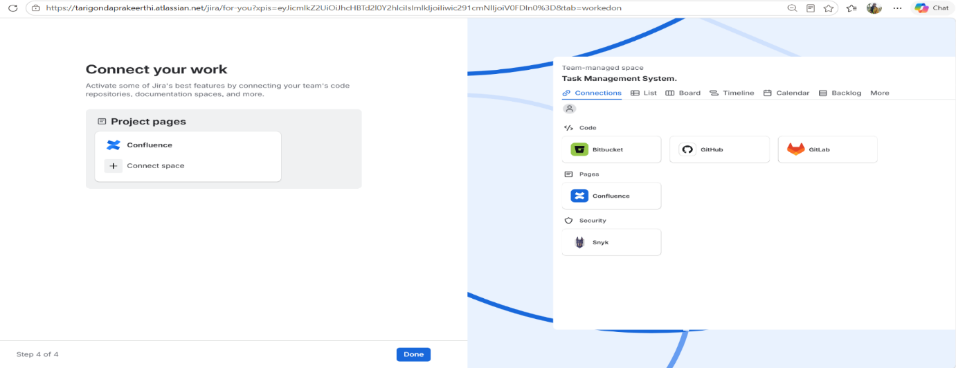
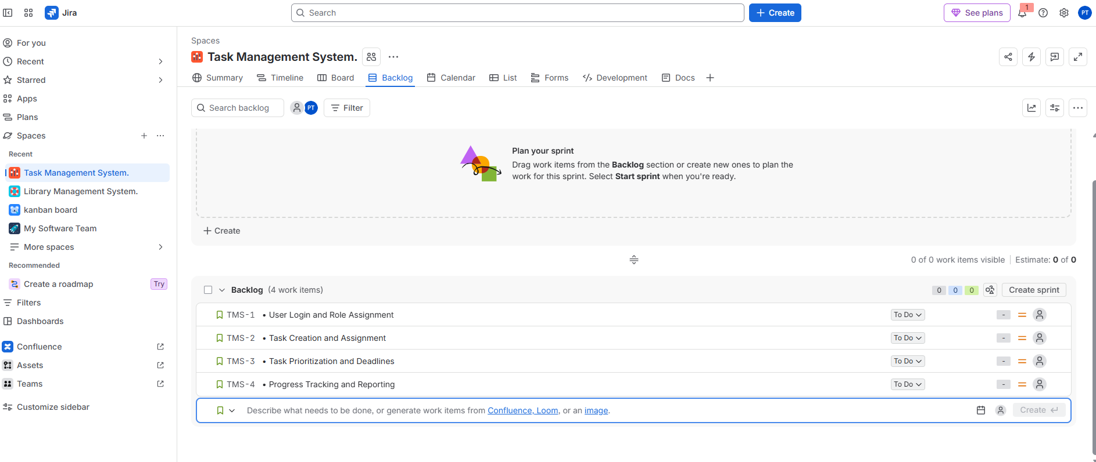
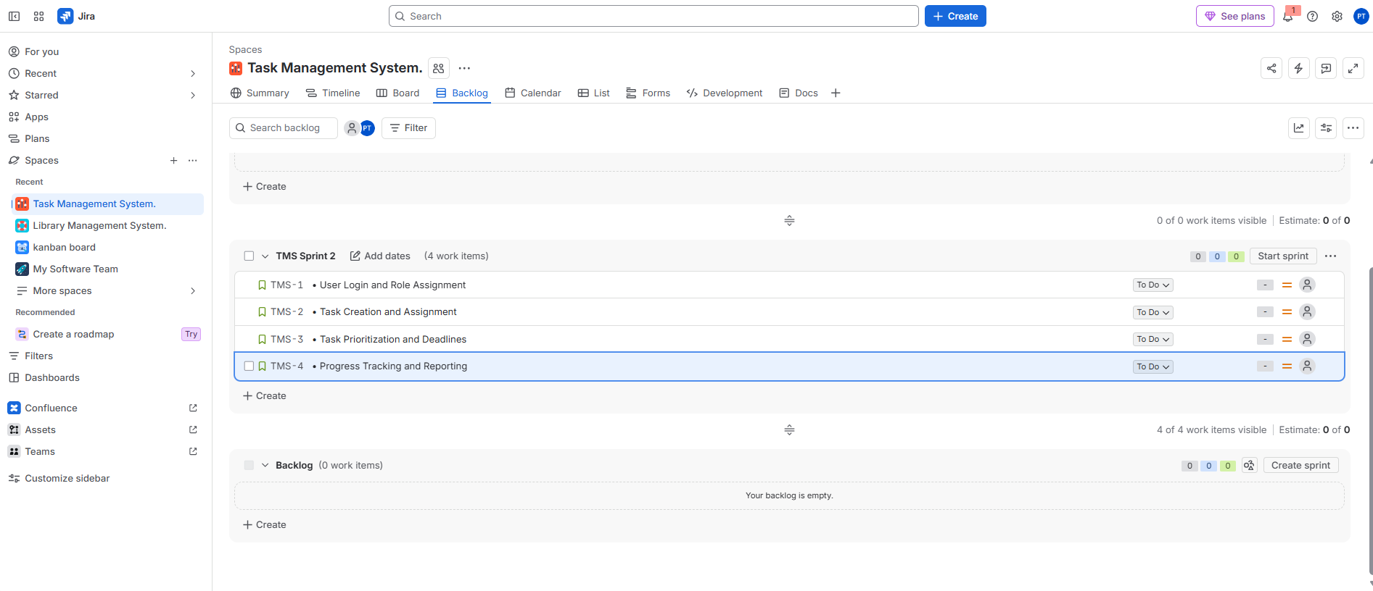
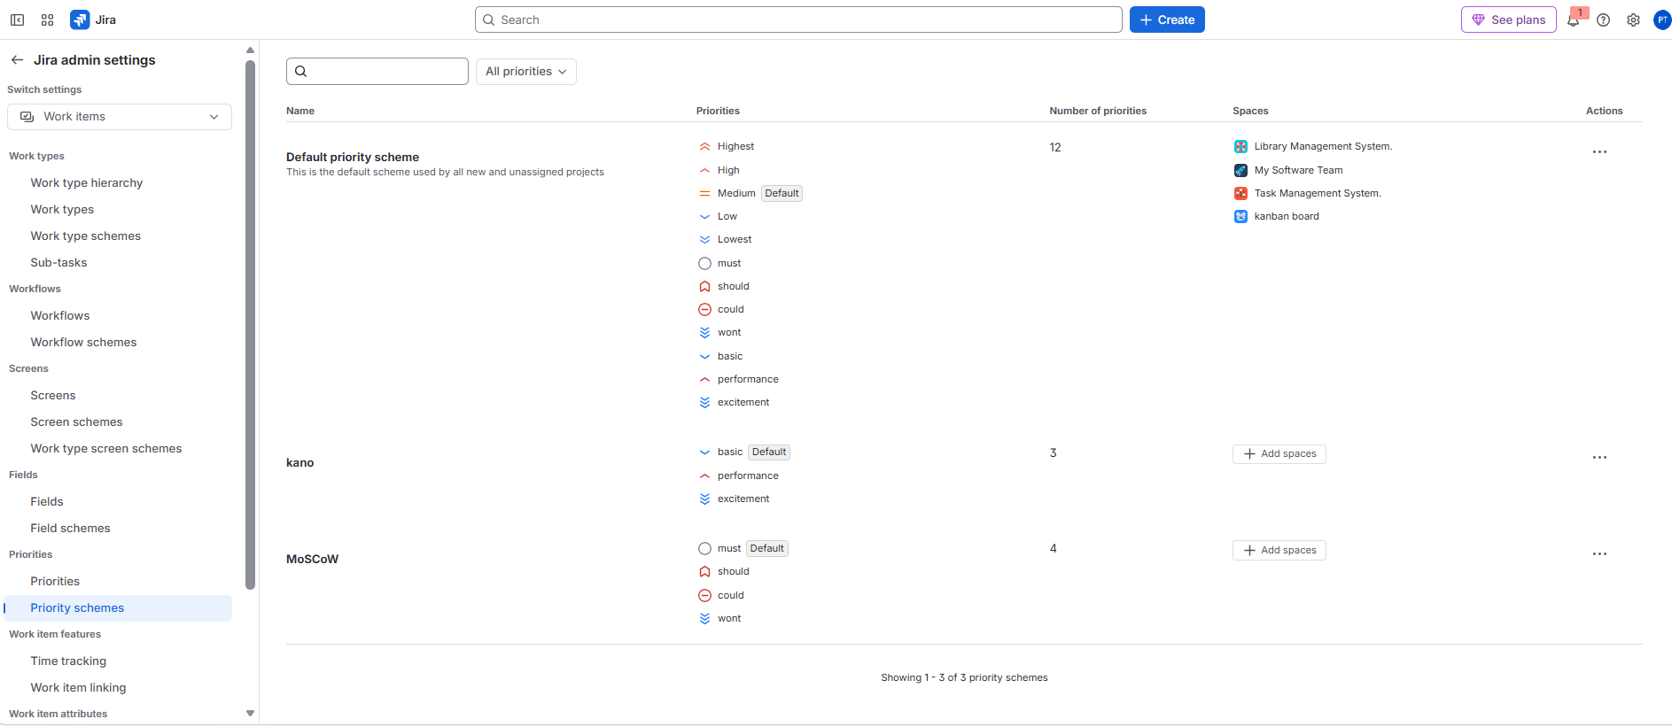
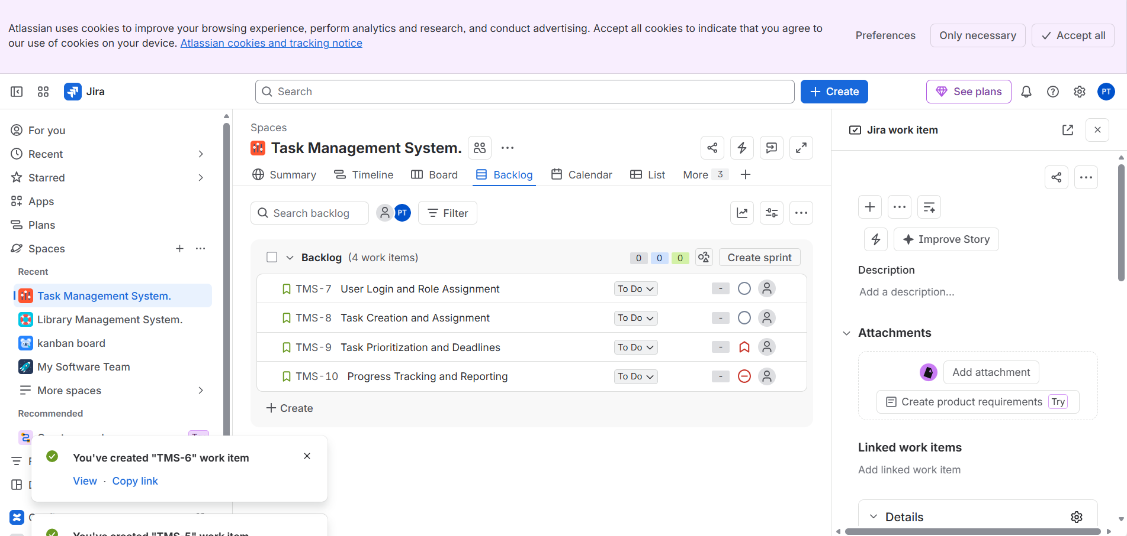
RESULT
Thus, the Task Management System requirements were successfully prioritized using the MoSCoW and Kano models in Jira. This helps identify essential features, organize development activities, allocate resources effectively, and improve project planning.

